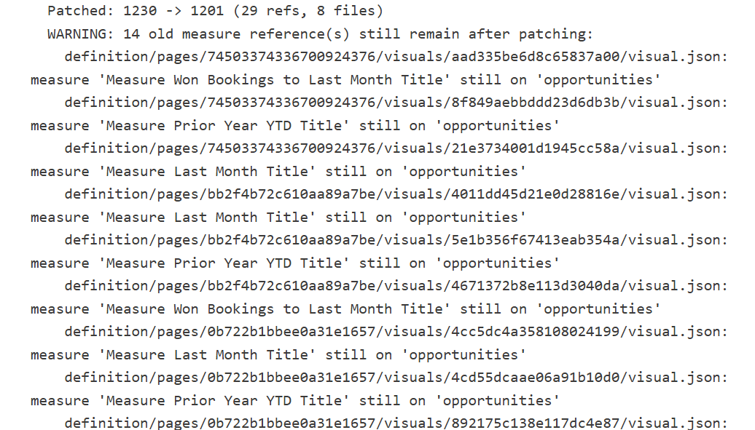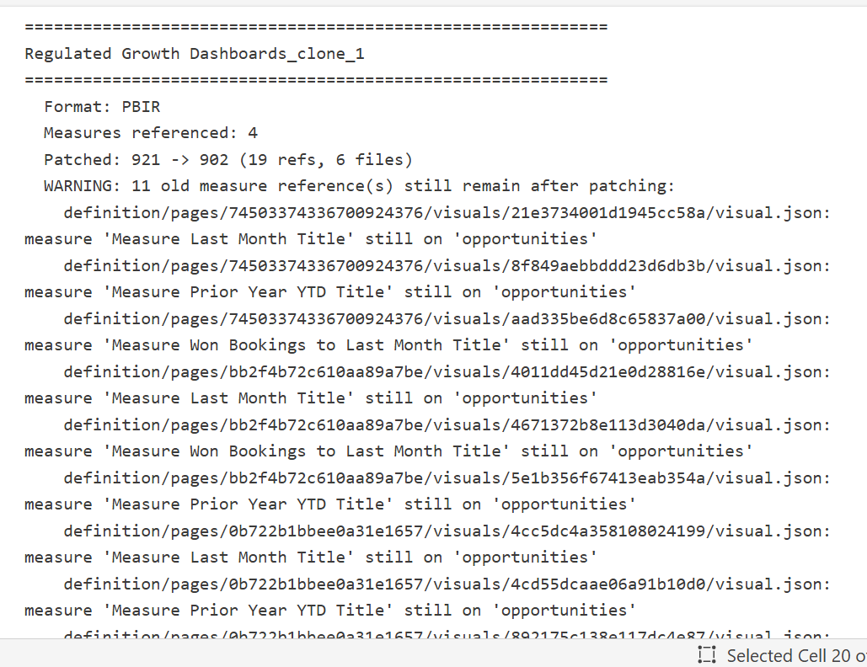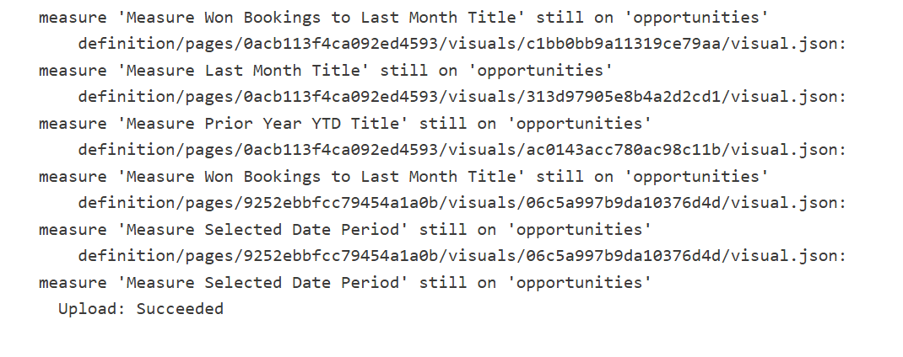

with labs.tom.connect_semantic_model(dataset=target_dataset, workspace=target_workspace, readonly=False) as tom:
move_list = []
for m in tom.all_measures():
if m.Parent.Name == measures_table_name:
continue
if measures_to_migrate is not None and m.Name not in measures_to_migrate:
continue
source_table = m.Parent.Name
if source_table.startswith(display_folder_prefix):
folder = source_table[len(display_folder_prefix):]
else:
folder = ""
move_list.append({
"name": m.Name, "expression": m.Expression, "format_string": m.FormatString,
"description": m.Description, "display_folder": folder,
"is_hidden": m.IsHidden, "source_table": source_table
})

if not move_list:
print("No measures to move.")
else:
print(f"Moving {len(move_list)} measures\n")

rewrites_total = 0
for info in move_list:
if not info['expression']:
continue
for other in move_list:
qualified_ref = f"'{other['source_table']}'[{other['name']}]"
unqualified_ref = f"[{other['name']}]"
if qualified_ref in info['expression']:
info['expression'] = info['expression'].replace(qualified_ref, unqualified_ref)
rewrites_total += 1
print(f" DAX fix: {info['name']} -> {qualified_ref} to {unqualified_ref}")
print(f"\n Rewrote {rewrites_total} qualified reference(s)\n" if rewrites_total else " DAX already clean\n")

# 3: Create measures table ONLY if it doesn't already exist
existing_table_names = {t.Name for t in tom.model.Tables}
if measures_table_name not in existing_table_names:
tom.add_calculated_table(name=measures_table_name, expression='{BLANK()}', hidden=True)
print(f"Created: {measures_table_name}")
else:
print(f"Using existing table: {measures_table_name}")

# 4: Remove originals
for info in move_list:
table = tom.model.Tables[info["source_table"]]
table.Measures.Remove(table.Measures[info["name"]])
print(f"Removed {len(move_list)} measures from source tables")

# 5: Add to _Measures with display folders
for info in move_list:
tom.add_measure(
table_name=measures_table_name, measure_name=info["name"],
expression=info["expression"], format_string=info["format_string"],
description=info["description"], display_folder=info["display_folder"],
hidden=info["is_hidden"]
)
print(f"Added {len(move_list)} measures to '{measures_table_name}'")

print("\nModel update complete. Open reports and verify.")
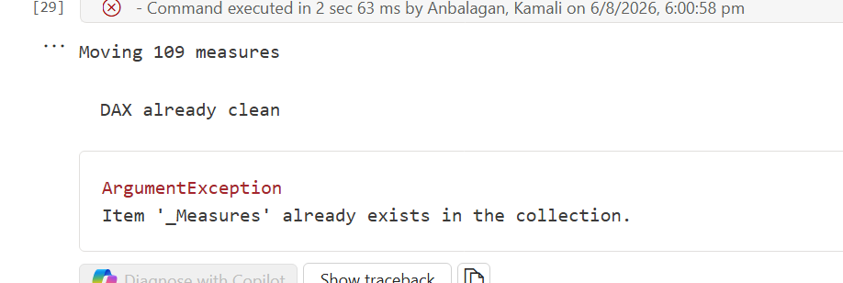
After changing the code also this gives error

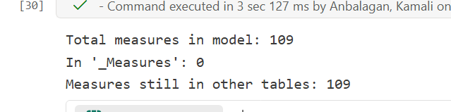

These are all the errors I faced during I work with another semantic model and reports

